

**UNIVERSITAS ESA UNGGUL**

**CSF101 ALGORITMA DAN PEMROGRAMAN KJ1001 7174**

**BUILDING CONCEPT OF PROJECT INITIATION – APLIKASI PEMINJAMAN DAN PENGEMBALIAN BUKU**

**TUGAS KELOMPOK 7 PROGRESS 2**

**Dosen Pengampu:**

**7174 - Ir. Sawali Wahyu, S.Kom., M.Kom**

**Kelompok 7:**

|  |  |  |
| --- | --- | --- |
| 1. **Muhamad Akbar Fadilah** | **-** | **20200801269** |
| 1. **Christian Niko Saputra** | **-** | **20240801295** |
| 1. **Denis Prastya Putra** | **-** | **20240801319** |
| 1. **Davina Tri Febriyanti** | **-** | **20240801361** |
| 1. **Arva Raihan Javier** | **-** | **20240801344** |

**PROGRAM STUDI SISTEM INFORMASI**

**FAKULTAS ILMU KOMPUTER**

**UNIVERSITAS ESA UNGGUL**

**TAHUN 2024**

# **DAFTAR ISI**

**DAFTAR ISI** 2

**PROJECT OVERVIEW** 3

**1.** **Deskripsi Proyek** 3

**2.** **Tujuan Proyek** 3

**3.** **Fitur** 3

**4.** **Pengguna Sistem** 3

**5.** **Teknologi yang Digunakan** 4

**FLOWCHART KONSEP APLIKASI** 5

**PSEUDOCODE APLIKASI** 6

**METODOLOGI PENGEMBANGAN SISTEM** 11

**HASIL AKHIR** 12

**1.** **Source Code** 12

**2.** **Link Github** 35

**3.** **Screenshot Aplikasi** 35

# **PROJECT OVERVIEW**

## **Deskripsi Proyek**

Aplikasi Peminjaman dan Pengembalian Buku adalah sistem manajemen perpustakaan digital yang dirancang untuk memudahkan proses administrasi perpustakaan. Sistem ini mengotomatisasi proses peminjaman dan pengembalian buku, serta memberikan visibilitas yang lebih baik terhadap inventaris perpustakaan.

## **Tujuan Proyek**

Dalam era digital yang terus berkembang, perpustakaan tradisional menghadapi tantangan signifikan dalam mengelola operasional mereka secara efisien dan efektif. Dengan mengadopsi teknologi terkini dan metodologi pengembangan yang tepat, sistem ini diharapkan dapat menjadi solusi komprehensif untuk berbagai permasalahan yang dihadapi perpustakaan. Adapun tujuan spesifik dari pengembangan proyek ini adalah:

* Meningkatkan efisiensi pengelolaan perpustakaan
* Meminimalisir kesalahan dalam pencatatan
* Mempermudah pelacakan status buku
* Menghasilkan laporan yang akurat tentang aktivitas perpustakaan

## **Fitur**

* 1. Manajemen Buku
     1. Pendaftaran buku baru
     2. Katalog buku digital
     3. Pencarian buku
     4. Pembaruan status buku
  2. Manajemen Anggota
     1. Pendaftaran anggota baru
     2. Pengelolaan profil anggota
     3. Riwayat peminjaman
     4. Status keanggotaan
  3. Transaksi
     1. Proses peminjaman buku
     2. Proses pengembalian buku
     3. Perpanjangan masa pinjam
     4. Perhitungan denda keterlambatan
  4. Pelaporan
     1. Laporan peminjaman
     2. Statistik buku populer
     3. Laporan keterlambatan

## **Pengguna Sistem**

* 1. Admin Perpustakaan
  2. Petugas Perpustakaan
  3. Supervisor/Kepala Perpustakaan

## **Teknologi yang Digunakan**

* 1. Bahasa Pemrograman:
     1. C++
  2. Struktur Data:
     1. Stack

1. **Development Tools**
   1. IDE dan Text Editor:
      1. Dev-C++
   2. Compiler:
      1. GNU G++
2. **Version Control**
   1. Git untuk manajemen versi kode
   2. GitHub untuk repositori dan kolaborasi
3. **Testing Tools**
   1. Unit Testing
      1. Pengujian fungsi-fungsi individual
      2. Validasi operasi stack

# **FLOWCHART KONSEP APLIKASI**

Flowchart ini menggambarkan alur kerja aplikasi Peminjaman & Pengembalian Buku yang mencakup interaksi pengguna, fungsi utama, dan hubungan antar data

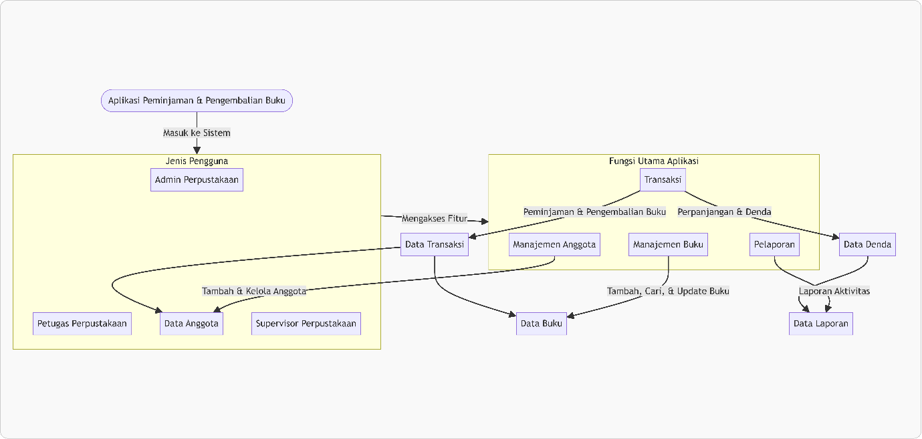

***Gambar 1 – Flowchart Konsep Aplikasi***

# **PSEUDOCODE APLIKASI**

// Global Data Structures

STRUCT Book

id: INTEGER

title: STRING

author: STRING

isAvailable: BOOLEAN

category: STRING

END STRUCT

STRUCT Member

id: INTEGER

name: STRING

membershipStatus: STRING

borrowedBooks: STACK OF INTEGER

END STRUCT

STRUCT Transaction

bookId: INTEGER

memberId: INTEGER

transactionType: STRING

date: STRING

dueDate: STRING

END STRUCT

STRUCT User

username: STRING

password: STRING

role: STRING

END STRUCT

// Main Program

PROCEDURE Main()

DECLARE loggedInUser: User

// Initialize default users

ADD admin credentials to users

ADD petugas credentials to users

ADD supervisor credentials to users

IF login(loggedInUser) THEN

DISPLAY "Login successful"

showMainMenu(loggedInUser)

ELSE

DISPLAY "Login failed"

END IF

END PROCEDURE

// Authentication

FUNCTION login(OUT loggedInUser: User) RETURNS BOOLEAN

INPUT username

INPUT password

FOR EACH user IN users DO

IF user.username = username AND user.password = password THEN

loggedInUser ← user

RETURN TRUE

END IF

END FOR

RETURN FALSE

END FUNCTION

// Main Menu

PROCEDURE showMainMenu(IN loggedInUser: User)

REPEAT

IF loggedInUser.role = "Admin" OR loggedInUser.role = "Supervisor" THEN

DISPLAY menu options for admin/supervisor

ELSE IF loggedInUser.role = "Petugas" THEN

DISPLAY menu options for petugas

END IF

INPUT choice

CASE choice OF

1: IF Admin/Supervisor THEN bookManagementMenu()

IF Petugas THEN transactionManagementMenu()

2: IF Admin/Supervisor THEN memberManagementMenu()

IF Petugas THEN EXIT

3: IF Admin/Supervisor THEN transactionManagementMenu()

4: IF Admin/Supervisor THEN reportMenu()

5: EXIT

END CASE

UNTIL choice = EXIT

END PROCEDURE

// Book Management

PROCEDURE bookManagementMenu()

REPEAT

DISPLAY book management options

INPUT choice

CASE choice OF

1: registerNewBook()

2: viewBookCatalog()

3: searchBook()

4: updateBookStatus()

5: deleteBook()

6: RETURN to main menu

END CASE

UNTIL choice = 6

END PROCEDURE

// Member Management

PROCEDURE memberManagementMenu()

REPEAT

DISPLAY member management options

INPUT choice

CASE choice OF

1: registerNewMember()

2: viewMember()

3: searchMember()

4: updateMemberProfile()

5: deleteMember()

6: RETURN to main menu

END CASE

UNTIL choice = 6

END PROCEDURE

// Transaction Management

PROCEDURE transactionManagementMenu()

REPEAT

DISPLAY transaction options

INPUT choice

CASE choice OF

1: borrowBook()

2: processReturning()

3: extendBorrowing()

4: deleteTransaction()

5: RETURN to main menu

END CASE

UNTIL choice = 5

END PROCEDURE

// Report Management

PROCEDURE reportMenu()

REPEAT

DISPLAY report options

INPUT choice

CASE choice OF

1: calculateLateFee()

2: viewTransactions()

3: RETURN to main menu

END CASE

UNTIL choice = 3

END PROCEDURE

END PROGRAM

# **METODOLOGI PENGEMBANGAN SISTEM**

Metode Waterfall adalah model pengembangan perangkat lunak yang mengikuti pendekatan linier dan berurutan, di mana setiap fase—mulai dari perencanaan, analisis kebutuhan, desain, implementasi, pengujian, hingga pemeliharaan—diselesaikan sepenuhnya sebelum beralih ke fase berikutnya.

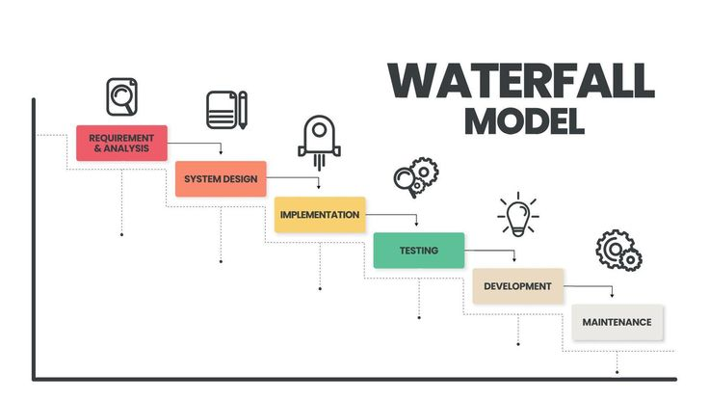

***Gambar 2 - Waterfall Model***

***(sumber: vecteezy.com)***

# **HASIL AKHIR**

## **Source Code**

*#include <iostream>*

*#include <stack>*

*#include <vector>*

*#include <string>*

*#include <sstream>*

*#include <iomanip>*

*#include <stdexcept>*

*#include <ctime>*

*using namespace std;*

*struct Book {*

*int id;*

*string title;*

*string author;*

*bool isAvailable;*

*string category;*

*};*

*struct Member {*

*int id;*

*string name;*

*string membershipStatus;*

*stack<int> borrowedBooks;*

*};*

*struct Transaction {*

*int bookId;*

*int memberId;*

*string transactionType; // Type: Borrow, Return, Extend*

*string date;*

*string dueDate;*

*};*

*struct User {*

*string username;*

*string password;*

*string role; // Role: Admin, Petugas, Supervisor*

*};*

*// Global Data*

*vector<Book> books;*

*vector<Member> members;*

*vector<Transaction> transactions;*

*vector<User> users;*

*// Utility functions*

*time_t parseDate(const string& dateStr) {*

*struct tm tm = {};*

*if (sscanf(dateStr.c_str(), "%d-%d-%d", &tm.tm_year, &tm.tm_mon, &tm.tm_mday) != 3) {*

*throw std::runtime_error("Invalid date format: " + dateStr);*

*}*

*tm.tm_year -= 1900; // Adjust year (tm_year is years since 1900)*

*tm.tm_mon -= 1; // Adjust month (tm_mon is 0-based)*

*return mktime(&tm);*

*}*

*string formatDate(time_t date) {*

*char buffer[11];*

*strftime(buffer, 11, "%Y-%m-%d", localtime(&date));*

*return string(buffer);*

*}*

*bool login(User& loggedInUser) {*

*string username, password;*

*cout << "Enter username: ";*

*cin >> username;*

*cout << "Enter password: ";*

*cin >> password;*

*for (const auto& user : users) {*

*if (user.username == username && user.password == password) {*

*loggedInUser = user;*

*return true;*

*}*

*}*

*return false;*

*}*

*// Function declarations*

*void registerNewBook();*

*void viewBookCatalog();*

*void searchBook();*

*void updateBookStatus();*

*void deleteBook();*

*void registerNewMember();*

*void viewMember();*

*void searchMember();*

*void updateMemberProfile();*

*void deleteMember();*

*void manageMemberProfile();*

*void viewBorrowHistory();*

*void processBorrowing();*

*void processReturning();*

*void extendBorrowing();*

*void calculateLateFee();*

*void borrowBook();*

*void viewTransactions();*

*void deleteTransaction();*

*void bookManagementMenu() {*

*int choice;*

*do {*

*cout << "\nBook Management\n";*

*cout << "1. Register New Book\n";*

*cout << "2. View Book Catalog\n";*

*cout << "3. Search Book\n";*

*cout << "4. Update Book Information\n";*

*cout << "5. Delete Book\n";*

*cout << "6. Back to Main Menu\n";*

*cout << "Enter your choice: ";*

*cin >> choice;*

*switch (choice) {*

*case 1:*

*registerNewBook();*

*break;*

*case 2:*

*viewBookCatalog();*

*break;*

*case 3:*

*searchBook();*

*break;*

*case 4:*

*updateBookStatus();*

*break;*

*case 5:*

*deleteBook();*

*break;*

*case 6:*

*return;*

*default:*

*cout << "Invalid choice. Please try again.\n";*

*}*

*} while (true);*

*}*

*void registerNewBook() {*

*Book newBook;*

*cout << "Enter book ID: ";*

*cin >> newBook.id;*

*cin.ignore();*

*cout << "Enter book title: ";*

*getline(cin, newBook.title);*

*cout << "Enter author: ";*

*getline(cin, newBook.author);*

*cout << "Enter category: ";*

*getline(cin, newBook.category);*

*newBook.isAvailable = true;*

*books.push_back(newBook);*

*cout << "Book registered successfully.\n";*

*}*

*void viewBookCatalog() {*

*cout << "\nBook Catalog:\n";*

*cout << "+------------+-----------------------------------------------+-----------------------------------------------+---------------------+----------------------+\n";*

*cout << "| Book ID | Title | Author | Category | Availability |\n";*

*cout << "+------------+-----------------------------------------------+-----------------------------------------------+---------------------+----------------------+\n";*

*bool found = false;*

*for (size_t i = 0; i < books.size(); ++i) {*

*cout << "| " << setw(10) << left << books[i].id*

*<< " | " << setw(45) << left << books[i].title*

*<< " | " << setw(45) << left << books[i].author*

*<< " | " << setw(19) << left << books[i].category*

*<< " | " << setw(20) << left << (books[i].isAvailable ? "Yes" : "No") << " |\n";*

*found = true;*

*}*

*if (!found) {*

*cout << "| Data books not found.\n";*

*}*

*cout << "+------------+-----------------------------------------------+-----------------------------------------------+---------------------+----------------------+\n";*

*}*

*void searchBook() {*

*string searchQuery;*

*cout << "Enter book title or author to search: ";*

*cin.ignore();*

*getline(cin, searchQuery);*

*bool found = false;*

*cout << "\nSearch Results:\n";*

*cout << "+------------+-----------------------------------------------+-----------------------------------------------+---------------------+----------------------+\n";*

*cout << "| Book ID | Title | Author | Category | Availability |\n";*

*cout << "+------------+-----------------------------------------------+-----------------------------------------------+---------------------+----------------------+\n";*

*for (size_t i = 0; i < books.size(); ++i) {*

*if (books[i].title.find(searchQuery) != string::npos || books[i].author.find(searchQuery) != string::npos) {*

*found = true;*

*cout << "| " << setw(10) << left << books[i].id*

*<< " | " << setw(45) << left << books[i].title*

*<< " | " << setw(45) << left << books[i].author*

*<< " | " << setw(19) << left << books[i].category*

*<< " | " << setw(20) << left << (books[i].isAvailable ? "Yes" : "No") << " |\n";*

*}*

*}*

*if (!found) {*

*cout << "| No books found matching your search criteria.\n";*

*}*

*cout << "+------------+-----------------------------------------------+-----------------------------------------------+---------------------+----------------------+\n";*

*}*

*void updateBookStatus() {*

*int bookId;*

*cout << "Enter book ID to update: ";*

*cin >> bookId;*

*cin.ignore();*

*for (size_t i = 0; i < books.size(); ++i) {*

*if (books[i].id == bookId) {*

*cout << "Enter new title (leave blank to keep current): ";*

*string newTitle;*

*getline(cin, newTitle);*

*if (!newTitle.empty()) books[i].title = newTitle;*

*cout << "Enter new author (leave blank to keep current): ";*

*string newAuthor;*

*getline(cin, newAuthor);*

*if (!newAuthor.empty()) books[i].author = newAuthor;*

*cout << "Enter new category (leave blank to keep current): ";*

*string newCategory;*

*getline(cin, newCategory);*

*if (!newCategory.empty()) books[i].category = newCategory;*

*cout << "Is the book available? (1 for Yes, 0 for No): ";*

*cin >> books[i].isAvailable;*

*cout << "Book updated successfully.\n";*

*return;*

*}*

*}*

*cout << "Book with ID " << bookId << " not found.\n";*

*}*

*void deleteBook() {*

*int bookId;*

*cout << "Enter book ID to delete: ";*

*cin >> bookId;*

*for (size_t i = 0; i < books.size(); ++i) {*

*if (books[i].id == bookId) {*

*books.erase(books.begin() + i);*

*cout << "Book deleted successfully.\n";*

*return;*

*}*

*}*

*cout << "Book with ID " << bookId << " not found.\n";*

*}*

*void memberManagementMenu() {*

*int choice;*

*do {*

*cout << "\nMember Management\n";*

*cout << "1. Register New Member\n";*

*cout << "2. View Member\n";*

*cout << "3. Search Member\n";*

*cout << "4. Update Member Profile\n";*

*cout << "5. Delete Member\n";*

*cout << "6. Back to Main Menu\n";*

*cout << "Enter your choice: ";*

*cin >> choice;*

*switch (choice) {*

*case 1:*

*registerNewMember();*

*break;*

*case 2:*

*viewMember();*

*break;*

*case 3:*

*searchMember();*

*break;*

*case 4:*

*updateMemberProfile();*

*break;*

*case 5:*

*deleteMember();*

*break;*

*case 6:*

*return;*

*default:*

*cout << "Invalid choice. Please try again.\n";*

*}*

*} while (true);*

*}*

*void registerNewMember() {*

*Member newMember;*

*cout << "Enter member ID: ";*

*cin >> newMember.id;*

*cin.ignore();*

*cout << "Enter member name: ";*

*getline(cin, newMember.name);*

*newMember.membershipStatus = "Active";*

*members.push_back(newMember);*

*cout << "Member registered successfully.\n";*

*}*

*void viewMember() {*

*cout << "\nMember Catalog:\n";*

*cout << "+------------+-----------------------------------------------+---------------------+\n";*

*cout << "| Member ID | Name | Status |\n";*

*cout << "+------------+-----------------------------------------------+---------------------+\n";*

*bool found = false;*

*for (size_t i = 0; i < members.size(); ++i) {*

*cout << "| " << setw(10) << left << members[i].id*

*<< " | " << setw(45) << left << members[i].name*

*<< " | " << setw(19) << left << members[i].membershipStatus << " |\n";*

*found = true;*

*}*

*if (!found) {*

*cout << "| Data members not found.\n";*

*}*

*cout << "+------------+-----------------------------------------------+---------------------+\n";*

*}*

*void searchMember() {*

*string searchQuery;*

*cout << "Enter member name to search: ";*

*cin.ignore();*

*getline(cin, searchQuery);*

*bool found = false;*

*cout << "\nSearch Results:\n";*

*cout << "+------------+-----------------------------------------------+---------------------+\n";*

*cout << "| Member ID | Name | Status |\n";*

*cout << "+------------+-----------------------------------------------+---------------------+\n";*

*for (size_t i = 0; i < members.size(); ++i) {*

*if (members[i].name.find(searchQuery) != string::npos) {*

*found = true;*

*cout << "| " << setw(10) << left << members[i].id*

*<< " | " << setw(45) << left << members[i].name*

*<< " | " << setw(19) << left << members[i].membershipStatus << " |\n";*

*}*

*}*

*if (!found) {*

*cout << "| No members found matching your search criteria.\n";*

*}*

*cout << "+------------+-----------------------------------------------+---------------------+\n";*

*}*

*void updateMemberProfile() {*

*int memberId;*

*cout << "Enter member ID to update: ";*

*cin >> memberId;*

*cin.ignore();*

*for (size_t i = 0; i < members.size(); ++i) {*

*if (members[i].id == memberId) {*

*cout << "Enter new name (leave blank to keep current): ";*

*string newName;*

*getline(cin, newName);*

*if (!newName.empty()) members[i].name = newName;*

*cout << "Enter new membership status (leave blank to keep current): ";*

*string newStatus;*

*getline(cin, newStatus);*

*if (!newStatus.empty()) members[i].membershipStatus = newStatus;*

*cout << "Member updated successfully.\n";*

*return;*

*}*

*}*

*cout << "Member with ID " << memberId << " not found.\n";*

*}*

*void deleteMember() {*

*int memberId;*

*cout << "Enter member ID to delete: ";*

*cin >> memberId;*

*for (size_t i = 0; i < members.size(); ++i) {*

*if (members[i].id == memberId) {*

*members.erase(members.begin() + i);*

*cout << "Member deleted successfully.\n";*

*return;*

*}*

*}*

*cout << "Member with ID " << memberId << " not found.\n";*

*}*

*void transactionManagementMenu() {*

*int choice;*

*do {*

*cout << "\nTransaction Management\n";*

*cout << "1. Borrow Book\n";*

*cout << "2. Return Book\n";*

*cout << "3. Extend Borrowing\n";*

*cout << "4. Delete Transaction\n";*

*cout << "5. Back to Main Menu\n";*

*cout << "Enter your choice: ";*

*cin >> choice;*

*switch (choice) {*

*case 1:*

*borrowBook();*

*break;*

*case 2:*

*processReturning();*

*break;*

*case 3:*

*extendBorrowing();*

*break;*

*case 4:*

*deleteTransaction();*

*break;*

*case 5:*

*return;*

*default:*

*cout << "Invalid choice. Please try again.\n";*

*}*

*} while (true);*

*}*

*void borrowBook() {*

*int bookId, memberId;*

*cout << "Enter Book ID to borrow: ";*

*cin >> bookId;*

*cout << "Enter Member ID: ";*

*cin >> memberId;*

*for (size_t i = 0; i < books.size(); ++i) {*

*if (books[i].id == bookId) {*

*if (!books[i].isAvailable) {*

*cout << "Book is currently not available.\n";*

*return;*

*}*

*for (size_t j = 0; j < members.size(); ++j) {*

*if (members[j].id == memberId) {*

*Transaction newTransaction;*

*newTransaction.bookId = bookId;*

*newTransaction.memberId = memberId;*

*newTransaction.transactionType = "Borrow";*

*time_t now = time(nullptr);*

*newTransaction.date = formatDate(now);*

*// Set tanggal jatuh tempo (7 hari dari sekarang)*

*time_t dueDate = now + 7 * 24 * 60 * 60;*

*newTransaction.dueDate = formatDate(dueDate);*

*// Simpan transaksi*

*transactions.push_back(newTransaction);*

*// Tandai buku sebagai tidak tersedia*

*books[i].isAvailable = false;*

*// Tambahkan buku ke daftar peminjaman anggota*

*members[j].borrowedBooks.push(bookId);*

*cout << "Book borrowed successfully. Due date: " << newTransaction.dueDate << "\n";*

*return;*

*}*

*}*

*cout << "Member not found.\n";*

*return;*

*}*

*}*

*cout << "Book not found.\n";*

*}*

*void processReturning() {*

*int bookId, memberId;*

*cout << "Enter Book ID to return: ";*

*cin >> bookId;*

*cout << "Enter Member ID: ";*

*cin >> memberId;*

*for (auto& transaction : transactions) {*

*if (transaction.bookId == bookId && transaction.memberId == memberId && transaction.transactionType == "Borrow") {*

*transaction.transactionType = "Return";*

*transaction.date = formatDate(time(nullptr));*

*for (auto& book : books) {*

*if (book.id == bookId) {*

*book.isAvailable = true;*

*break;*

*}*

*}*

*for (auto& member : members) {*

*if (member.id == memberId) {*

*if (!member.borrowedBooks.empty() && member.borrowedBooks.top() == bookId) {*

*member.borrowedBooks.pop();*

*}*

*break;*

*}*

*}*

*cout << "Book returned successfully.\n";*

*return;*

*}*

*}*

*cout << "No active borrowing transaction found for the given Book ID and Member ID.\n";*

*}*

*void deleteTransaction() {*

*int bookId, memberId;*

*cout << "Enter Book ID: ";*

*cin >> bookId;*

*cout << "Enter Member ID: ";*

*cin >> memberId;*

*for (size_t i = 0; i < transactions.size(); ++i) {*

*if (transactions[i].bookId == bookId && transactions[i].memberId == memberId) {*

*transactions.erase(transactions.begin() + i);*

*cout << "Transaction deleted successfully.\n";*

*return;*

*}*

*}*

*cout << "Transaction not found.\n";*

*}*

*void extendBorrowing() {*

*int bookId, memberId;*

*cout << "Enter Book ID: ";*

*cin >> bookId;*

*cout << "Enter Member ID: ";*

*cin >> memberId;*

*for (auto& t : transactions) {*

*if (t.bookId == bookId && t.memberId == memberId && t.transactionType == "Borrow") {*

*time_t dueDate = parseDate(t.dueDate);*

*dueDate += 7 * 24 * 60 * 60; // Extend by 7 days*

*t.dueDate = formatDate(dueDate);*

*t.transactionType = "Extend";*

*cout << "Borrowing period extended successfully. New due date: " << t.dueDate << "\n";*

*return;*

*}*

*}*

*cout << "Transaction not found or not eligible for extension.\n";*

*}*

*// Reports Menu*

*void reportMenu() {*

*int choice;*

*do {*

*cout << "\nReports\n";*

*cout << "1. Calculate Late Fee\n";*

*cout << "2. View Transactions\n";*

*cout << "3. Back to Main Menu\n";*

*cout << "Enter your choice: ";*

*cin >> choice;*

*switch (choice) {*

*case 1:*

*calculateLateFee();*

*break;*

*case 2:*

*viewTransactions();*

*break;*

*case 3:*

*return;*

*default:*

*cout << "Invalid choice. Please try again.\n";*

*}*

*} while (true);*

*}*

*void viewTransactions() {*

*cout << "\nTransaction History:\n";*

*cout << "+------------+------------+----------------+------------+------------+\n";*

*cout << "| Book ID | Member ID | Transaction | Date | Due Date |\n";*

*cout << "+------------+------------+----------------+------------+------------+\n";*

*for (const auto& t : transactions) {*

*cout << "| " << setw(10) << left << t.bookId*

*<< " | " << setw(10) << left << t.memberId*

*<< " | " << setw(14) << left << t.transactionType*

*<< " | " << setw(10) << left << t.date*

*<< " | " << setw(10) << left << t.dueDate << " |\n";*

*}*

*cout << "+------------+------------+----------------+------------+------------+\n";*

*}*

*void calculateLateFee() {*

*int bookId, memberId;*

*cout << "Enter Book ID: ";*

*cin >> bookId;*

*cout << "Enter Member ID: ";*

*cin >> memberId;*

*for (const auto& t : transactions) {*

*if (t.bookId == bookId && t.memberId == memberId && t.transactionType == "Borrow") {*

*time_t dueDate = parseDate(t.dueDate);*

*time_t currentDate = time(nullptr);*

*if (currentDate > dueDate) {*

*int daysLate = (currentDate - dueDate) / (24 * 60 * 60);*

*int lateFee = daysLate * 5000; // Late fee: 5000 per day*

*cout << "Book is late by " << daysLate << " days. Late fee: Rp " << lateFee << "\n";*

*} else {*

*cout << "No late fee. Book is returned on time.\n";*

*}*

*return;*

*}*

*}*

*cout << "Transaction not found or not eligible for late fee calculation.\n";*

*}*

*void showMainMenu(User& loggedInUser) {*

*int choice;*

*do {*

*cout << "\nLibrary Management System\n";*

*if (loggedInUser.role == "Admin") {*

*cout << "1. Book Management\n";*

*cout << "2. Member Management\n";*

*cout << "3. Transactions\n";*

*cout << "4. Reports\n";*

*cout << "5. Exit\n";*

*}*

*else if (loggedInUser.role == "Petugas") {*

*cout << "1. Transactions\n";*

*cout << "2. Exit\n";*

*}*

*else if (loggedInUser.role == "Supervisor") {*

*cout << "1. Book Management\n";*

*cout << "2. Member Management\n";*

*cout << "3. Transactions\n";*

*cout << "4. Reports\n";*

*cout << "5. Exit\n";*

*}*

*cout << "Enter your choice: ";*

*cin >> choice;*

*switch (choice) {*

*case 1:*

*if (loggedInUser.role == "Admin" || loggedInUser.role == "Supervisor") {*

*bookManagementMenu();*

*}*

*else if (loggedInUser.role == "Petugas") {*

*transactionManagementMenu();*

*}*

*break;*

*case 2:*

*if (loggedInUser.role == "Admin" || loggedInUser.role == "Supervisor") {*

*memberManagementMenu();*

*}*

*else if (loggedInUser.role == "Petugas") {*

*transactionManagementMenu();*

*}*

*break;*

*case 3:*

*if (loggedInUser.role == "Admin" || loggedInUser.role == "Supervisor") {*

*transactionManagementMenu();*

*}*

*break;*

*case 4:*

*if (loggedInUser.role == "Admin" || loggedInUser.role == "Supervisor") {*

*reportMenu();*

*}*

*break;*

*case 5:*

*if (loggedInUser.role == "Admin" || loggedInUser.role == "Supervisor") {*

*cout << "Exiting the system.\n";*

*return;*

*}*

*else if (loggedInUser.role == "Petugas") {*

*cout << "Exiting the system.\n";*

*return;*

*}*

*break;*

*default:*

*cout << "Invalid choice. Please try again.\n";*

*}*

*} while (true);*

*}*

*// Main function*

*int main() {*

*users.push_back({"admin", "admin123", "Admin"});*

*users.push_back({"petugas", "petugas123", "Petugas"});*

*users.push_back({"supervisor", "supervisor123", "Supervisor"});*

*User loggedInUser;*

*if (login(loggedInUser)) {*

*cout << "Login successful! Welcome, " << loggedInUser.username << "\n";*

*showMainMenu(loggedInUser);*

*}*

*else {*

*cout << "Login failed! Please check your credentials.\n";*

*}*

*return 0;*

*}*

## **Link Github**

[*https://github.com/akbarfdlh2/Tugas-Kelompok-7*](https://github.com/akbarfdlh2/Tugas-Kelompok-7)

## **Screenshot Aplikasi**

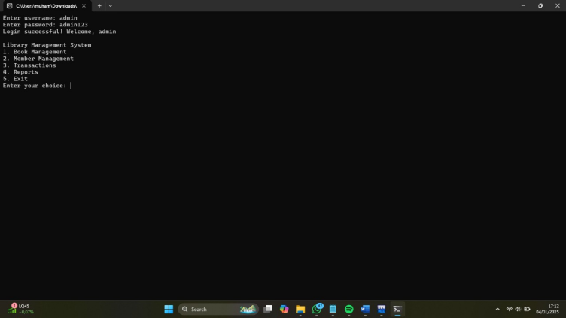

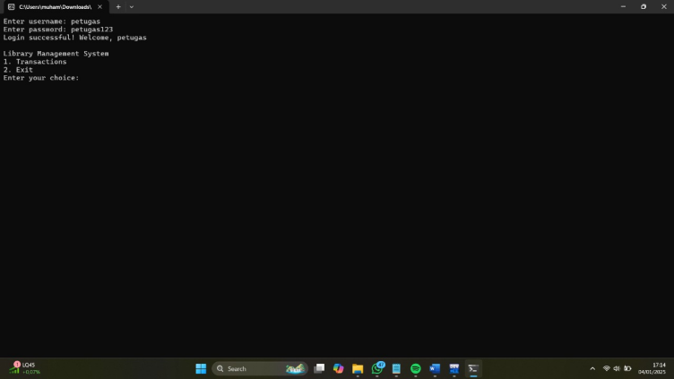

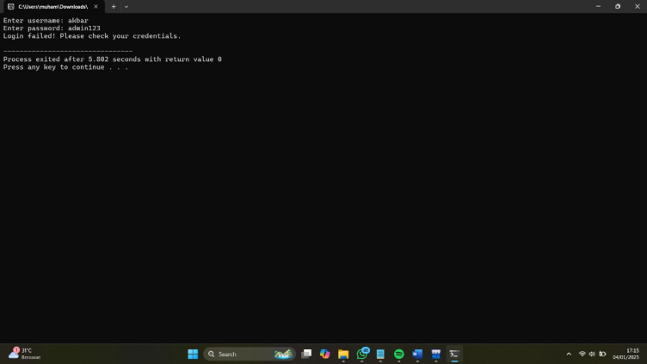

**Gambar 3 - Login**

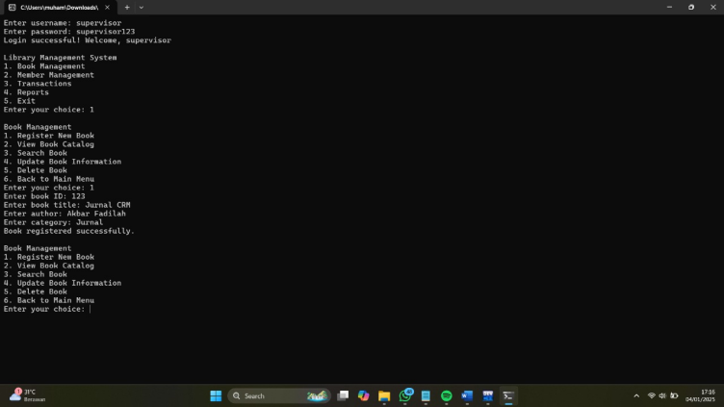

**Gambar 4 - Register New Book**

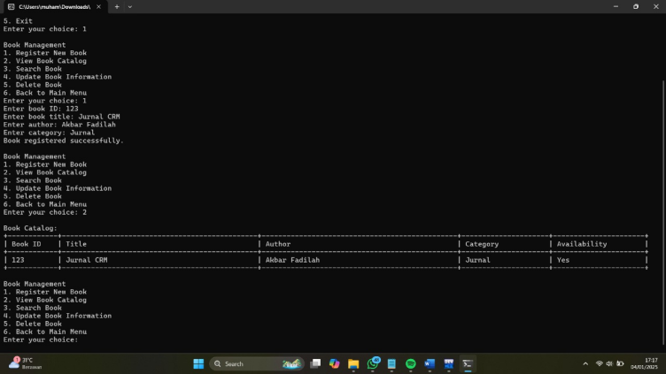

**Gambar 4 - View Book Catalog**

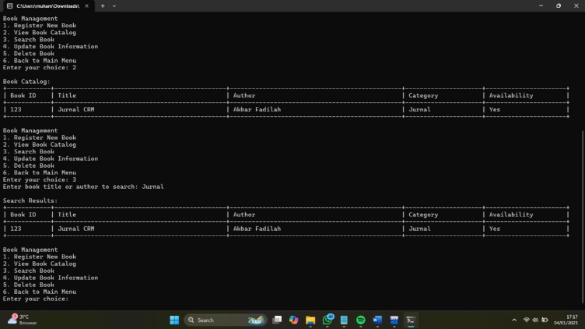

**Gambar 5 - Search Book**

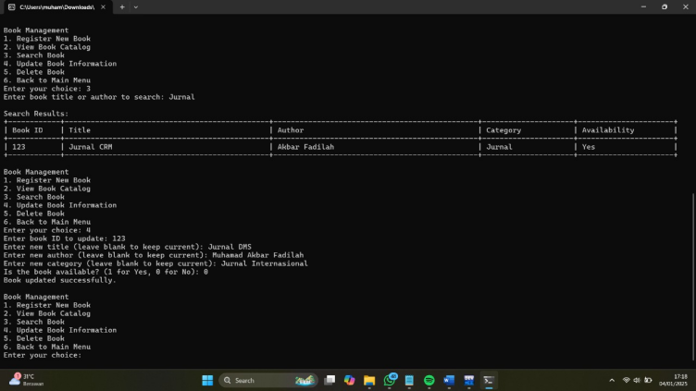

**Gambar 6 - Update Book Information**

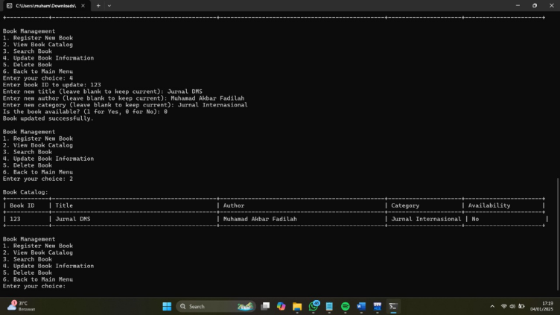

**Gambar 7- View Book Catalog (After Update)**

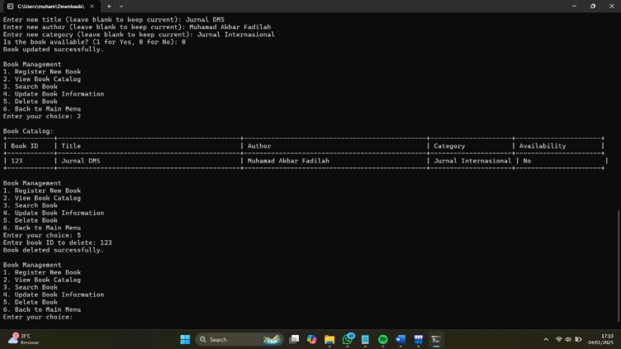

**Gambar 8 - Delete Book**

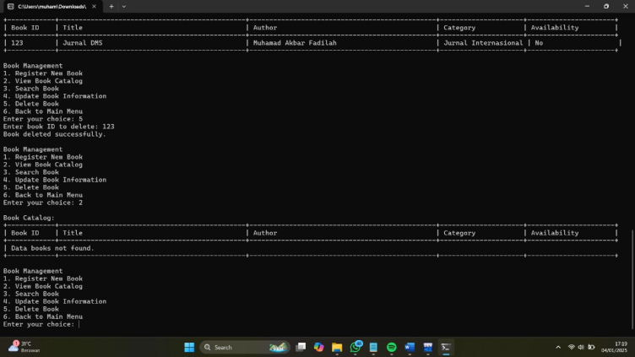

**Gambar 8 - View Book Catalog (After Delete)**

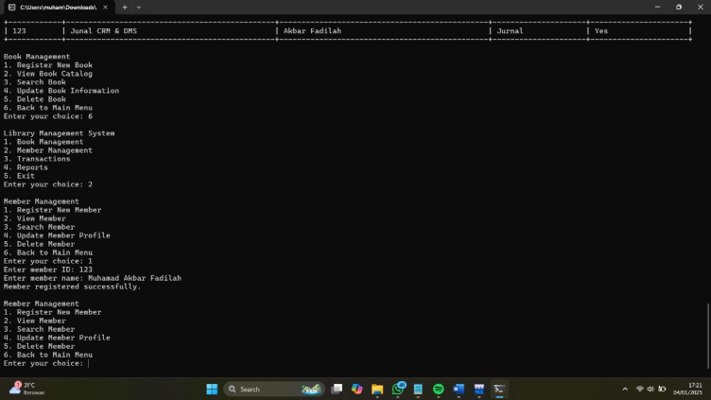

**Gambar 9 - Register New Member**

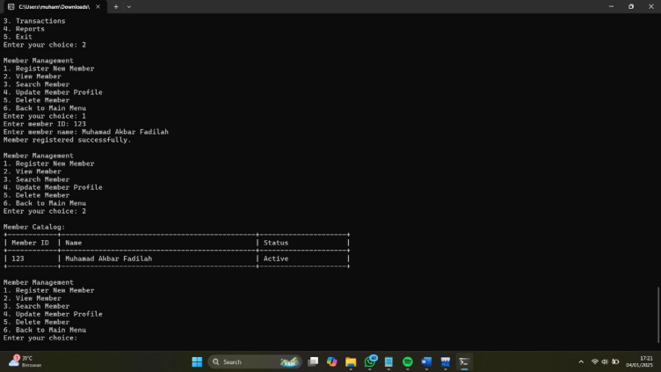

**Gambar 9 - View Member**

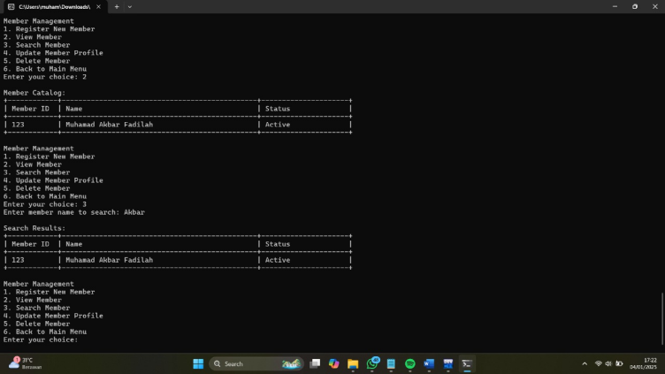

**Gambar 10 - Search Member**

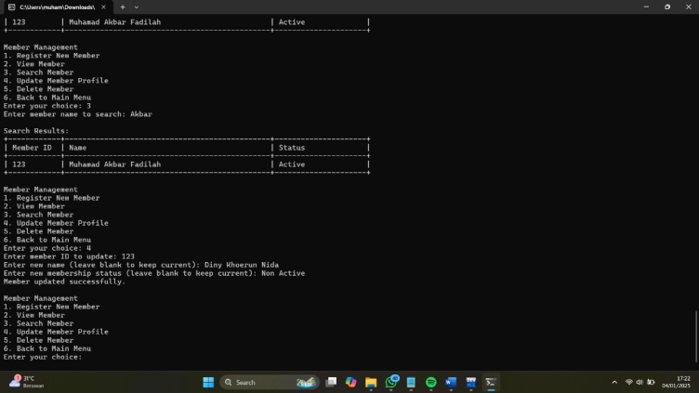

**Gambar 11 - Update Member Profile**

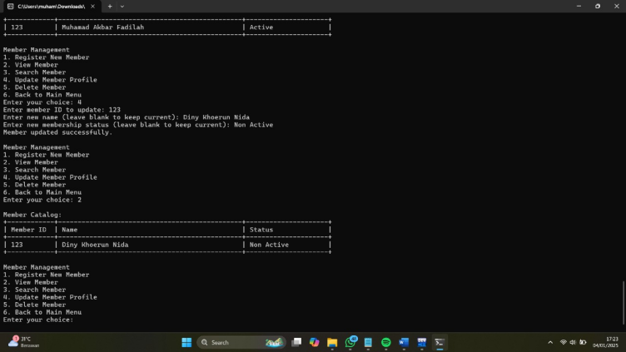

**Gambar 12 - View Member (After Update)**

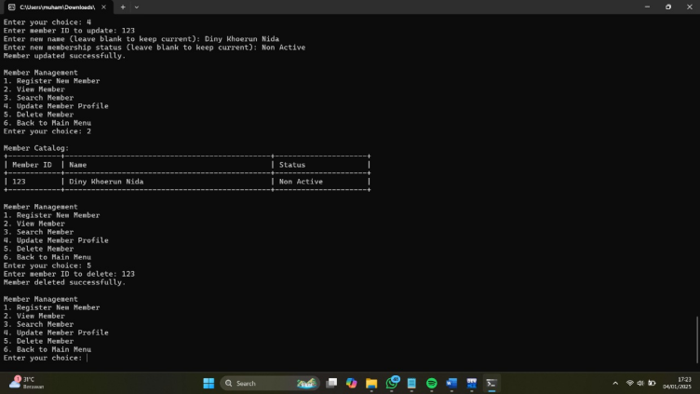

**Gambar 13 - Delete Member**

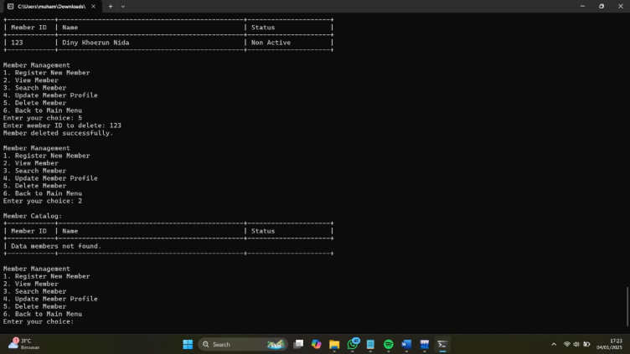

**Gambar 14 - View Member (After Delete)**

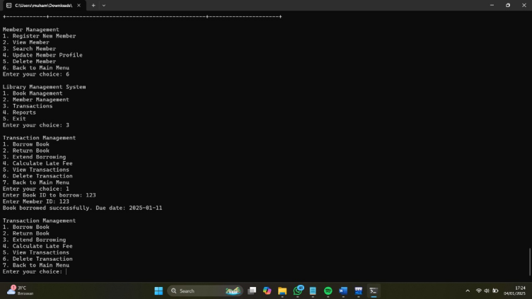

**Gambar 15 - Borrow Book**

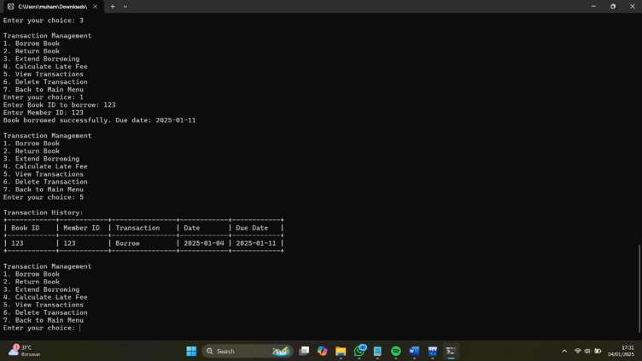

**Gambar 16 - View Transactions (After Borrow Book)**

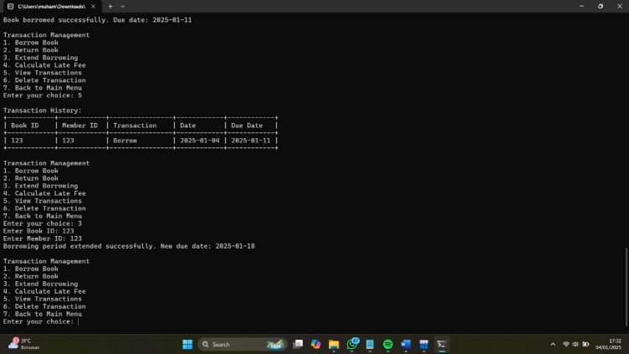

**Gambar 17 - Extend Borrowing**

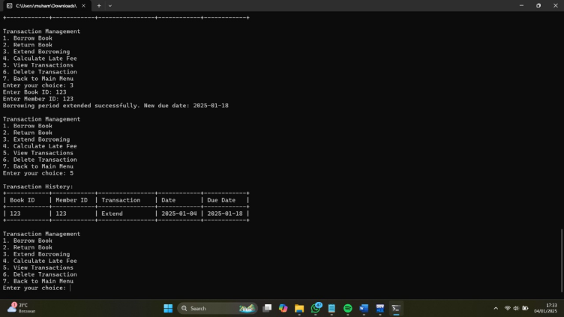

**Gambar 18 - View Transactions (After Extend Borrowing)**

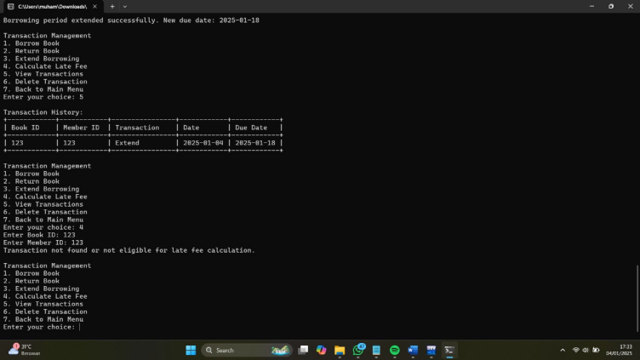

**Gambar 19 - Return Book**

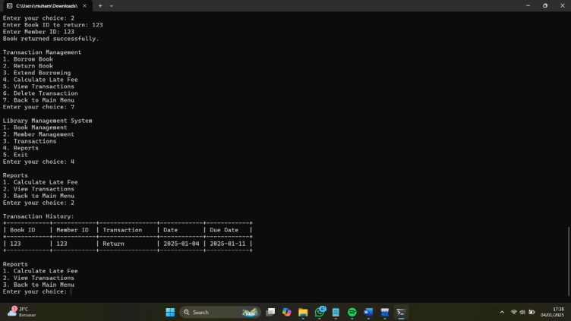

**Gambar 20 - View Transaction (After Return)**